Fundist.org: Operator’s user manual for WLC Edition
Version | Date | Commentary
0.5 | 17 April 2010 | First version of Fundist Operator’s User Manual
1.0 | 05 June 2010 | Second version of Fundist Operator’s User Manual
2.0 | 15 September 2013 | Renewed version for WLC products, split off from betting shops version (removed unnecessary screens)
3.0 | 09 June 2014 | New features added, main language is now English language, discarded Russian language version from core.

1 – Introduction
  - Fundist.org specification
Fundist.org is built using open-source software and doesn’t require the casino to purchase any additional software licenses. Fundist.org is a fully open solution to the client - the client can opt out for a completely managed solution, where all changes and new functionality are being added by our engineers, or if the client has the team of his own, he can fully manage most of the product
Fundist.org is the Payment System and Casino Builder Platform for Physical Betting Shops and Client Web Sites. Fundist.org provides all the required functionality for running a successful modern casino, and includes the following modules as a part of standard package:
Module | Description
User Management | All standard user management is included in the solution
Reporting | Turnover reports at Network, Kiosk (Site), User level, audit logs, Transaction reports (Account Statement)
User-level admin | User-level information and administration on a single-customer-view basis
Game systems | All major gaming platforms are supported. Inquire with the sales managers to find out more.
Payment systems | We support all major payment systems and can develop ad hoc integration with payment systems of the client’s choice. The client is the owner of the secret keys for payments, therefore there is no need to entrust us with the keys to funds and there is no risk of payment system keys to be hacked or obtained from Fundist.org. This is extremely important for running a proper white label casino that nobody on the market currently offers.
Templating engine | Templates are provided using Twig templating language, which is one of the most robust and flexible templates available, with possibility to sandbox the design templates against hacks and programmers’ bugs.
White Label Casino Core System | White Label Casino Core System allows on the fly remotes updates, so that all fixes to the core can be introduced as soon as they are available without the need for extensive integration and regression testing on the client side.
Content Management System | As standard we provide a drop-in CMS with Wordpress. Any other CMS can be easily supported (including your existing CMS), as Fundist.org is not integrated into any CMS solution. Wordpress CMS provides templating,
Loyalty and Experience System | Both experience (betting) based system (experience points that lead to levelling up or down) and loyalty points (credits that can be used to purchase items) system are supported with full administration rights provided to the client. A flexible mixed system of both experience and loyalty points is easy to implement.
Anti-Fraud System | Integration with payment systems anti-fraud tools is provided. Possbility of configuring min and max payments is possible.
CRM System | A fully functional CRM is built into Fundist.org. An extract export is supported for Sugar CRM.
Bonus System | All types of event based bonuses are supported with full admin rights for bonus management provided to the client.
Due-diligence and documentation management | If required, document management and due diligence is supported for collecting required documentation from the players.
Affiliate System | As standard we provide data feeds to two of the most popular affiliate networks or a possibility to add a data feed into an affiliate management software.
Web Analytics | As standard we include integration with Google Analytics.
Multi-language | Multilanguage, Unicode is supported at all levels of the system. New languages can be easily added by using PO files.
Multi-currency | Virtually all currencies are supported.
Event-based marketing | Possibility to create dynamic lists based on particular events and send them automatic emails allows you to retain and activate your user base without additional expense.
Social networks support | Support for social network logins of all the major networks plus ad hoc networks as needed by the client.
Self-hosted or software as a service options | The architecture of Fundist.org platform allows the client to host the platform entirely on its own servers
Clusters, Content Delivery Network | Fundist.org platform supports CDN and cluster architecture, which means that the client can run the casino, locally hosting the files closer to the client base (for example – hosting one version of the site in Japan and another in Germany), all synchronization work is being done by WLC engine. Major CDNs are supported.

  - Hierarchy in Fundist.org
There are three tier levels in Fundist.org structure
Hierarchy level | Description
Network | Network is the highest hierarchy level available to you. A network is your total business, that consists of web sites or physical shops, that are represented by kiosks.
Kiosk (site) | Kiosk can be a physical betting shop location or a web site. If your kiosk is a web site, it will have an API connection exclusively created for this particular kiosk. A user is unique at kiosk level. If you have two separate web sites, they can still be joined under one network, so you can control them with a single view. If you want to create several skins of one site, then you should use one kiosk and change the skins on the client side.
User (player) | A user or player is owned by a particular kiosk (site). You can create a user manually in case you have a betting shop or some VIP who you want to present with an account, or (usually) the client would register himself.

  - User types
There are four basic levels of users in Fundist.org:
User type | Description
Network Operator | Main user, this is the only user that Fundist.org creates for you. Network operator can create as many other operators as needed, and assign login and password to them. Network Operator sees all the Kiosks under his network (including audit log and turnovers of all kiosks), can create, enable, disable users and kiosks, can add or remove credits to and from a particular kiosk. Network operator does not have rights to work with transactions at kiosk-user level (for accountability purposes).
Kiosk Operator | This is the operator of a particular kiosk, with possibility of adding / removing funds from the clients, viewing turnover reports, accepting withdrawal requests, using CRM, enabling / disabling users, viewing audit logs.
Cashier | Cashier has the same functionality as the Kiosk Operator minus ability to create users and access audit log and view the turnover report.
Kiosk Support | Ability to answer support queries, use CRM module. Kiosk Support does not have access to financial transactions (cannot add or remove funds).

2 – Logging in
Operator’s admin enters the system via this address: https://www.fundist.org
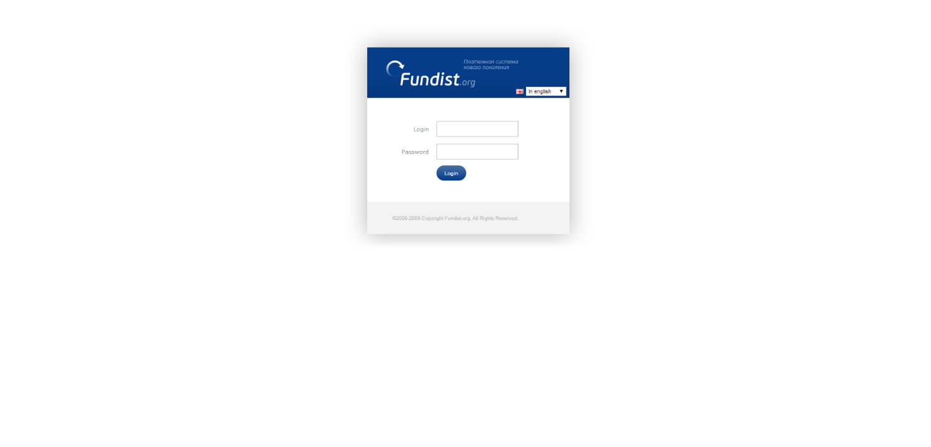

2 – Change password
If this is your first login into the system, Fundist.org will prompt you to change the password. Make sure that your password is at least 8 characters long and does not use simple to guess combinations.
WARNING! Please makre sure that you remember yopur password and do not allow several people to use the same account, otherwise you will not be able to track the responsible person in case of any problems or issues!
If you have several employees who need to have Network Operator or Kiosk Operator privileges, create as many additional users as needed, and if an employee leaves your company, disable the user!
What if your employee forgets a passowrd?
Main Network Operator (your main responsible person) can change the password of any Network Operator or Kiosk Operator at any time. During the next login the user will be prompted to enter a new password.
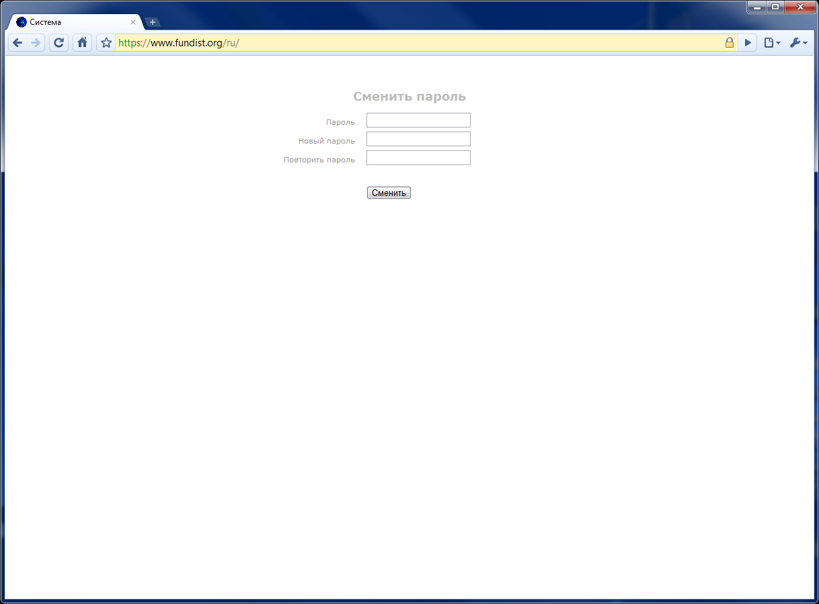
3 – Users tab
Once you enter into the system, you will see the list of all the users in your network (or kiosk, if you login as a kiosk operator). Here you can see the newly registered users, search for a particular user using many parameters and go into user-level screens. You can also create a user manually, by entering required info on the left part of the screen.
Kiosk operator can also add funds or remove funds from a particular user, disable the user and edit information of the user, including changing the user level.
User list can be sorted by registration date, balance, profit from the client.
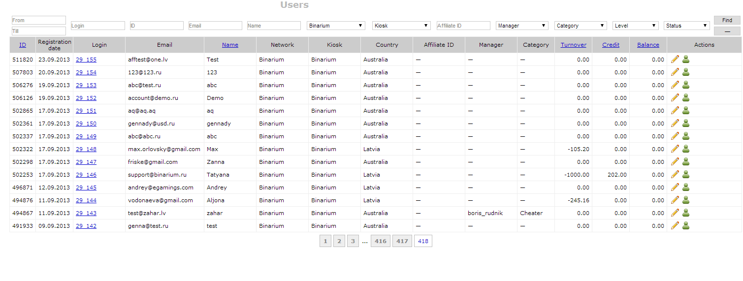
Here are the main filter criteria in more detail:
You can select the to and from dates for client registration, login name, ID, email, name, affiliate ID, assigned manager (CRM / support functionality), Client Category, Level, Status.
Working with the user list – commands
Button | Action
 | Edit user information
 | Disable / enable user. A disabled user can no longer enter into the system. A reason for disabling (and reenabling) is recorded and IP address and login name of the operator who made the decision is also recorded in the audit log.
 | You can add funds to the user by pressing this button. Funds are added in the player currency.
 | You can remove funds from the user by pressing this button. Funds are removed in the player currency.
Login name | Click the login name to go to the client summary view (see below).

3.1 – Main menu: user name and balance
In the right-hand corner of the screen you see information about the particular user (your user name, your user role, your network, and the balance of your network if you are a Network Operator or your kiosk). The balances system is a good way to manage risks, as you can set your balance at your daily or weekly turnover, which will mean that in case of any issues there is a limit to the amount of funds that can be credited to a particular user.
IMPORTANT! All balances in Fundist.org are counted in Euro (EUR) for internal accounting, although balances of players are stored in their native currencies.
You can also see two links – Change Password for changing your password and Logout, for correctly finishing the work in the Fundist.org system.
IMPORTANT! Please make sure that you click Logout if you finished working with the system and you use a computer that can be used by somebody else.
3.2 – User Summary View
This is the main user screen, where you can see most of the information on a particular user and access other modules switched on for your casino.
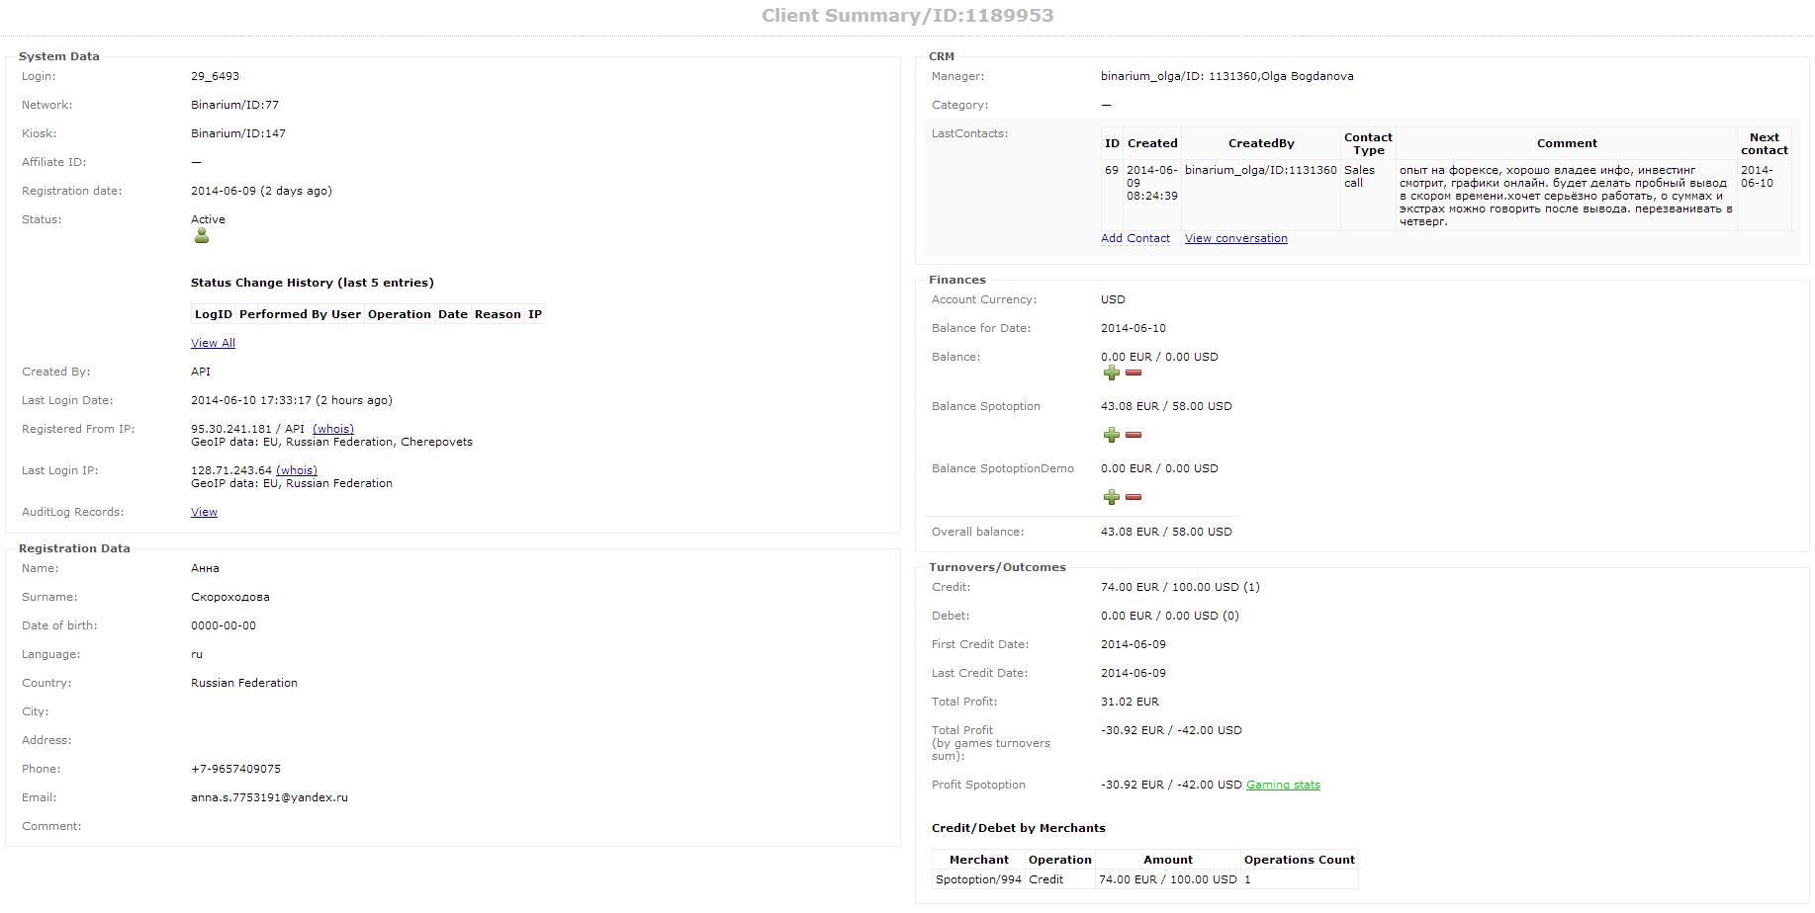
As there is a lot of information on that particular screen, it is divided into five parts, let’s see each of those parts separately:
3.2.1. System data
On this particular part you can see the main system data (login name, network and kiosk, date of registration, affiliate ID, status (active/disabled), history of statuses (whether the player was disabled or re-enabled, by who and for what reason), you can also see which IP / country the client registered from and which IP/country the client logged in from the last time. Finally, you can access the audit log where you can see all activity of that particular user.
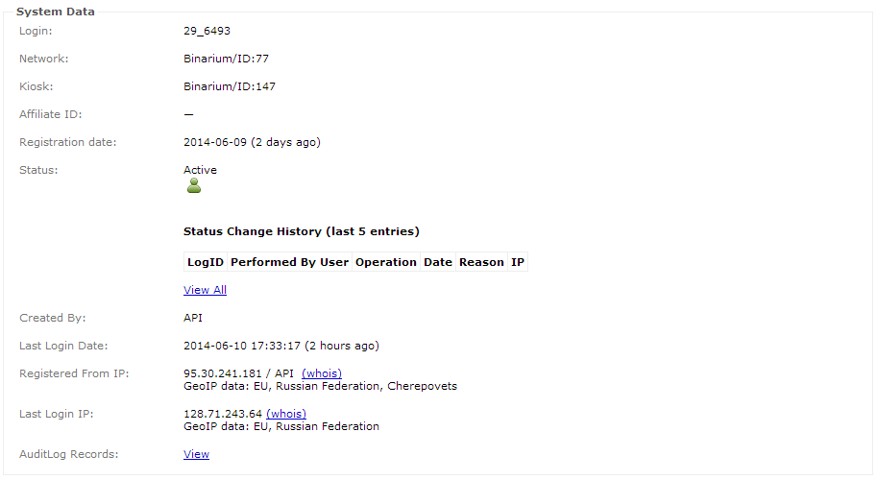
3.2.2. Registration data
This is the part, where you can see all registration data provided by the user, including name, surname, language, country, date of birth (if required), address, telephone, email address, and any other custom fields you decide to use.
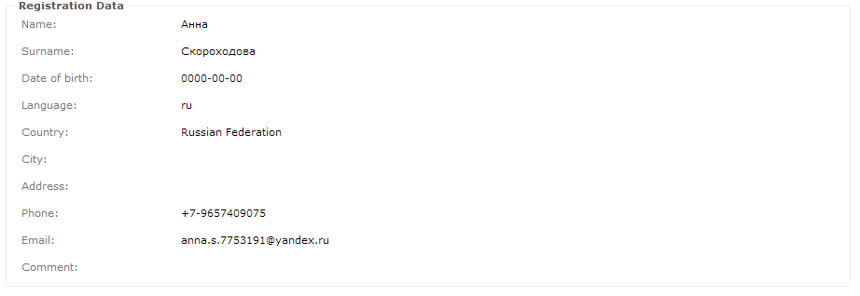
3.2.3. Finances
In this part you can see the user’s currency, see the balances of the user in any of the game systems that you have, add and remove funds.

3.2.4. Turnovers / Outcomes
In this part of the screen you can see mainly financial information – what is the number and amount of debits and credits, when was the first and last deposit date, what is the total profit from the client, and profit split by gaming system. You will also see the summary by number of debits and credits grouped by a particular gaming system.
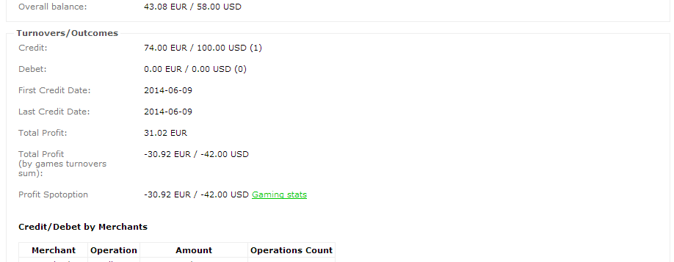
3.2.5. CRM
In this section you can see the last CRM messages and add a new contact or view the list of all contacts with the client. You can also assign a manager for the particular client and you can view who is the assigned manager.
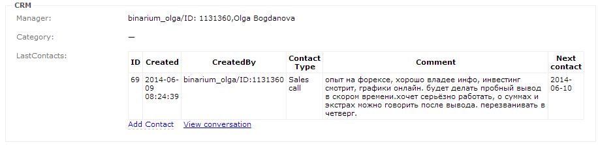
When adding a new contact, you can select the type of contact and the next contact date/time. Operations and next contact options are configurable for a particular casino operator.
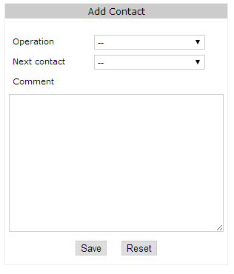
4.1 – Reports: turnovers
Turnovers report is the main report by which you can see the profitability of your casino. You can view it at the highest level as a network operator, at a kiosk level if you are the kiosk operator. You can dig down into the report, by looking at the list of users, and you can analyze a particular user for any discrepancies. The turnover report is provided at a monthly and daily level. The last day profitability is provided, recalculated every 10 or so minutes for separate wallet systems and at near real time for single-wallet systems.
In the turnover report you can see the deposits, withdrawals, balances and turnovers. If your casino has more than one gaming systems, you will see a separate column for each such gaming system.
Here’s the turnover report at a summary level: (monthly)
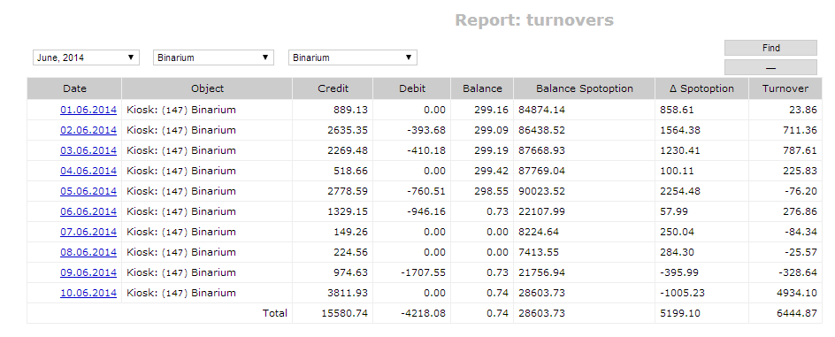
Here’s the drill-down report, at a daily level, where you can see all the users active today, view their game system statistics for this particular day and access their summary reports. You can also sort easily to show the biggest winners and losers.
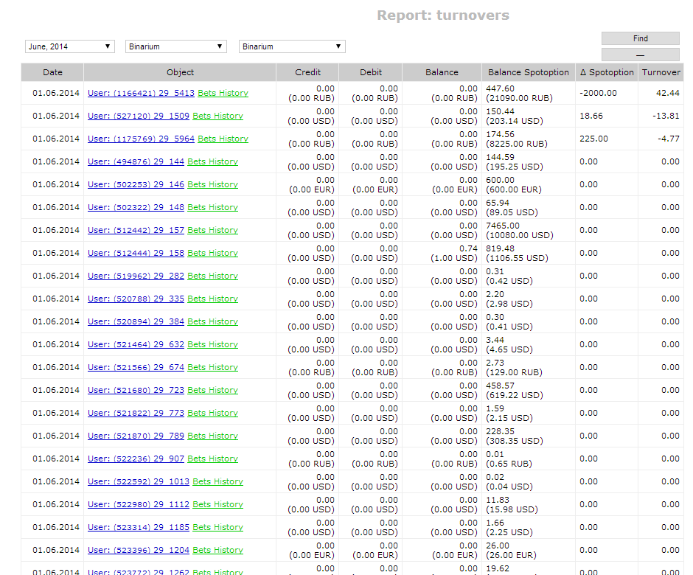

4.2. Transaction report
Each user has a transaction report which can be viewed just as you would view an account statement of a bank account. Here’s how it looks like:
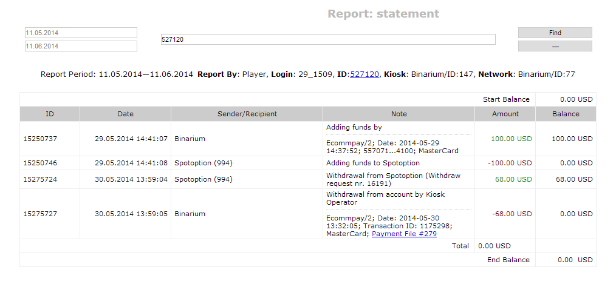
In that report you can see all transactions of the user, payment system information and withdrawal information. For each transaction both the transaction amount and the end balance are recorded in the player’s currency. All manual transactions are also shown in this report, together with a comment.
5 – Audit log
Audit logs show any and all activities for your casino, recording all information, including the user who caused an activity, an object, changed information, etc. All errors are also stored in the audit log. The audit log can easily be used to filter a particular group of messages (for example, see only errors).
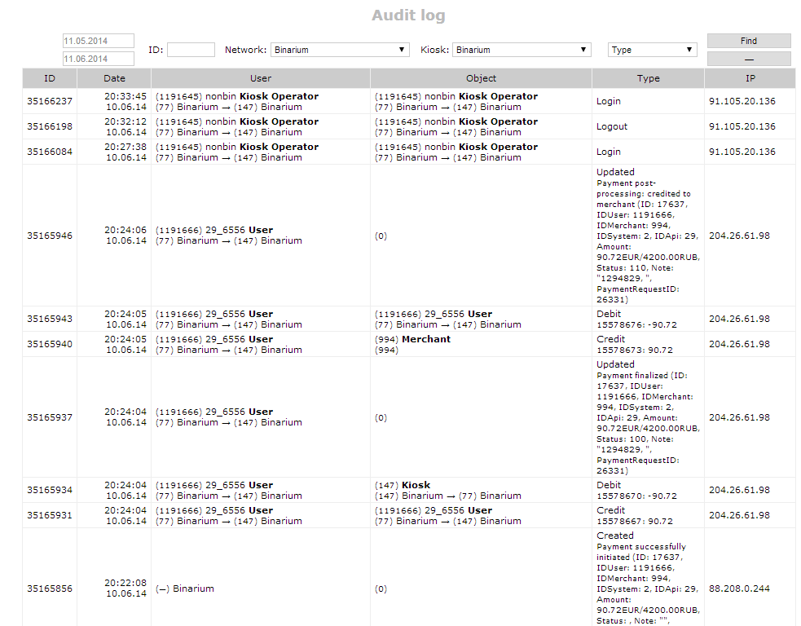

6 – Payment authorization and payment files
Payments requested by users are stored in the payment queue that needs to be accepted by the kiosk operator. Once the payments are accepted, they are included into the batch payment files, which are then executed by the manager (if needed, you can separate this process to prevent any internal fraud or forgery).
Once you accept the payments, they are automatically debited from the user, unless the user doesn’t have enough funds, which will mean that the withdrawal request will be withdrawn (you have an option to either reserve the withdrawal amount, or leave it for the user to use before the payment is reviewed by the kiosk operator). The operator can refuse the withdrawal request and provide a reason for that. This reason will be visible to the user.
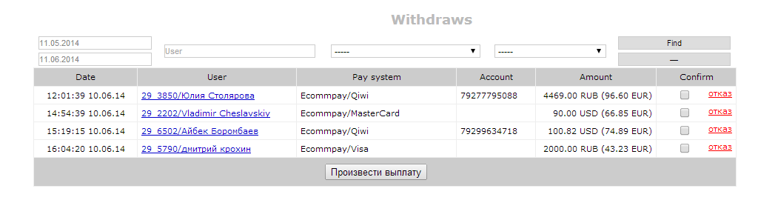
Payment files
You can create as many payment files, as you want, depending on your internal workflows (for example, you can process withdrawal requests daily, or hourly).
You can see the payment files for historical purposes and bookkeeper can easily do a reconciliation between the data recorded in Fundist.org and the payment systems.
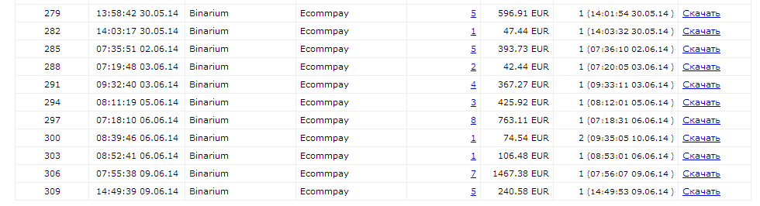
Incoming payments
All incoming payments are recorded as well, and you can easily view the statistics for incoming payments at a daily view and drill down within each day to see the deposit details. Any rejected or incomplete deposits will also be visible for CRM work and support.
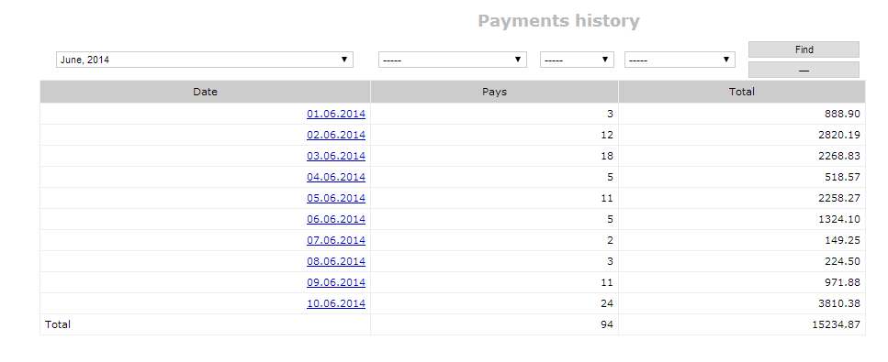
7 – Mailing lists
You can automate mailing lists based on many filters. Here’s the example of a mailing list creation tool. You create the list using filters on the left, and either manually download the list or automatically integrate with a maillist service.
This allows you to send welcome letters to each new client, to send emails to clients who did not login for over x months, clients who made the first deposit, etc.
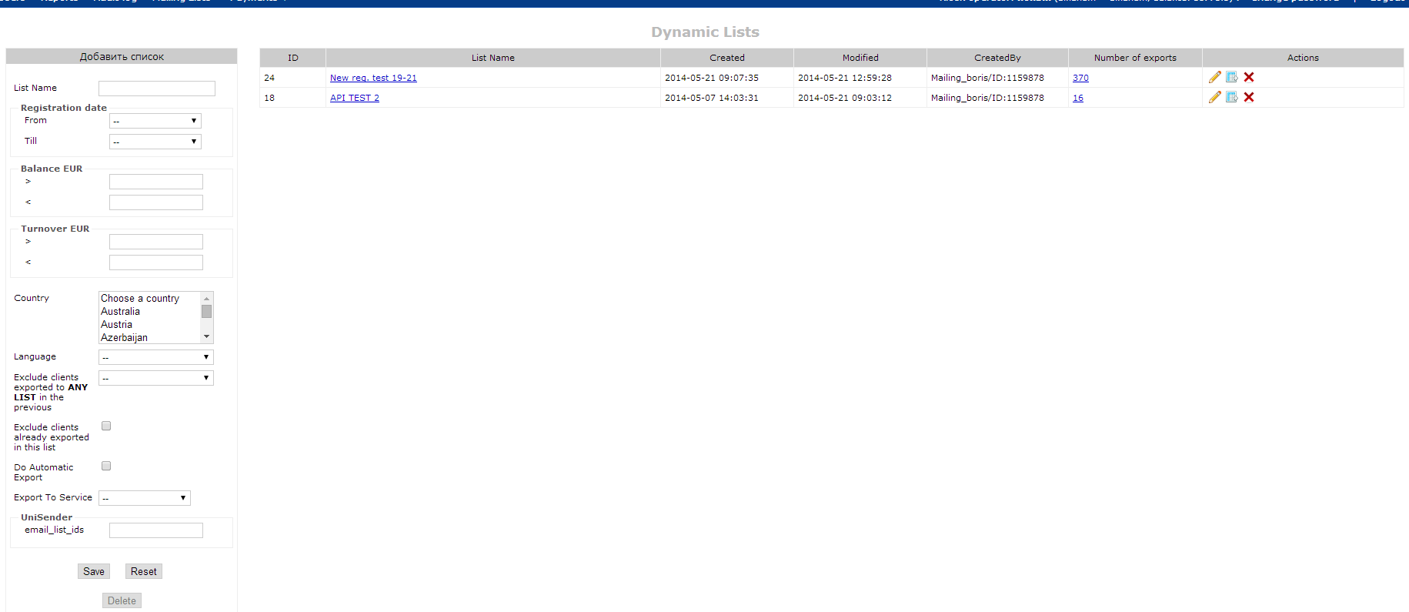
8 – Loyalty and experience system
Loyalty is a bet based system, that motivates user to make more bets to get more experience and loyalty points. Experience points allows user to move up from level to level getting more effective bet-to-points conversion coefficient. As well as loyalty points can be spent in loyalty store.
Loyalty system consists from several parts:
Level setup
For each level you can provide name, level up (points needed to move to next level) and level hold (points to stay on current level by month close) points and conversion coefficient.
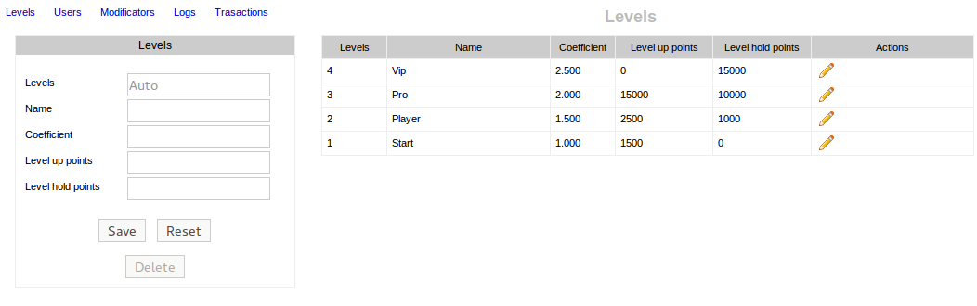
Loyalty users
This sections allows to control users, credit or debit their experience points, change level, etc.
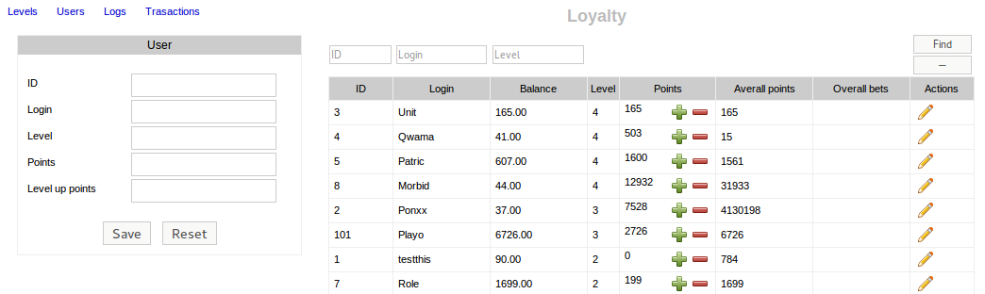
Logs
Section contain information about all bets registered in loyalty system in a certain period. As well as all changes done by those bets – e.g. points credited, levels, etc.
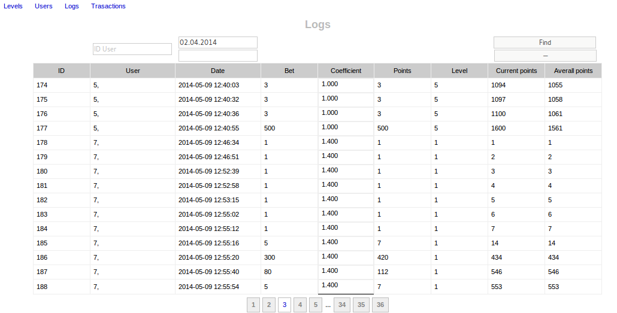
Transactions
Sections display all loyalty balance changes.
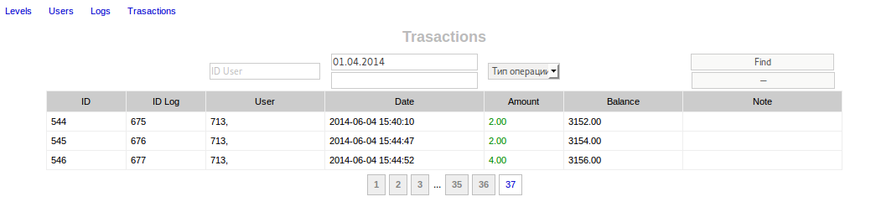

Loyalty system also available for integration through API interface.

9 – Bonus system
Bonus managing system includes different aspect preferences that allows to setup bonuses for any individual purposes.
Main preferences
Set base bonus preferences: name, activation promo code, turn on event, repeats – how often user can subscribe for the bonus, budget, availability period. “Save As” button used to clone current bonus with new name.
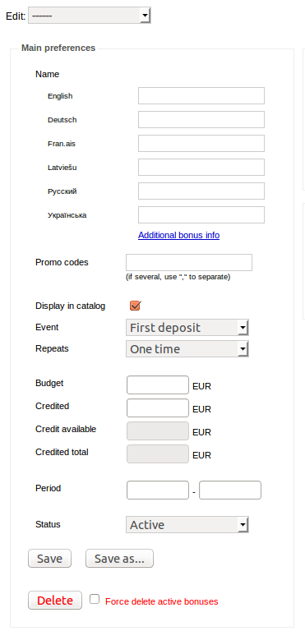
Additional bonus info – allow to set up short and detailed bonus description and bonus images.
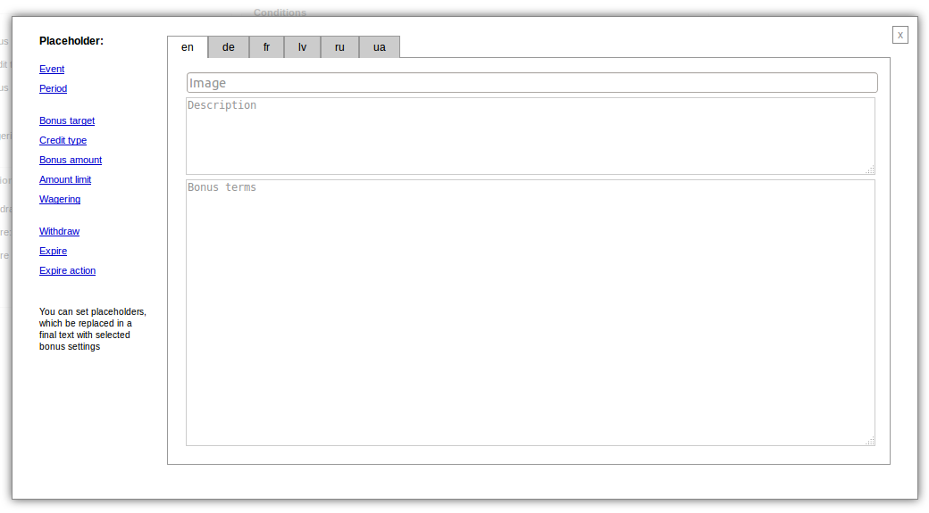
Results
Provide managing of bonus turn on parameters: target of bonus credit (balance, experience points, loyalty points), credit type (absolute or relative), amount (bonus value), amount limit and wagering. Alignment allow to set more user friendly numbers for different currencies.
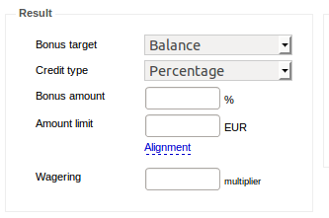
Limitations
Set limitations on withdraws while bonus is active. Can limit all funds, bonus amount or winning amount. Also setup action to do when bonus expires.
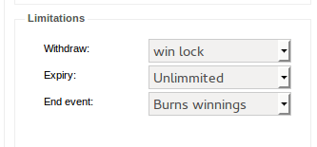
Conditions
Conditions section consist of a several parts:
Overall
Allow or restric stack with other bonuses. Select levels that will be able to get bonus.
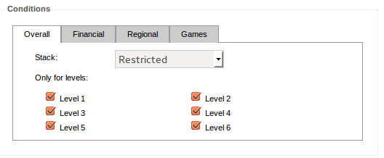
Financial
Setup minimum-maximum event amount which triggers bonus switch on (and alignment for different currencies). Also pay system and currency conditions.
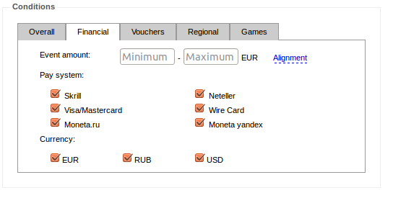

Vouchers
Bonus can be subscribed by using voucher code. Each voucher code is uniq and can be user only once. You can generate different batches of codes with own prefix and get statistic about used codes.
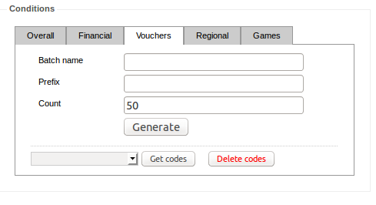
Regional
Allows to set up regions and/or languages where bonus will be available or restricted
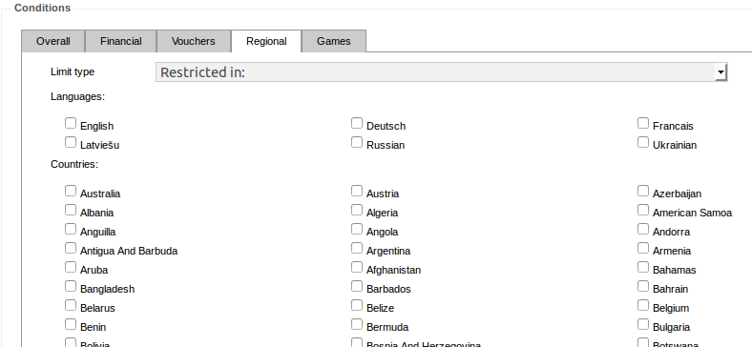
Games
Provides section to select games that wagers the bonus and additional wagering coefficients based on math expectations.

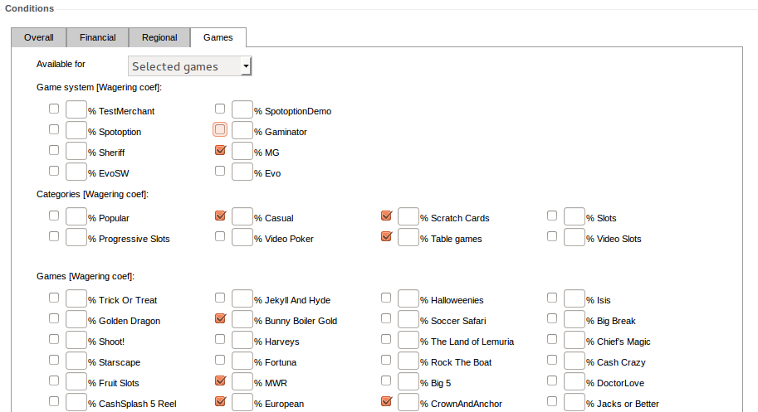
Bonus reports
Overall report shows bonus current state – current budget, total credit and credit left amount, users with activated bonus, amount of users with expired/canceled or winned bonus
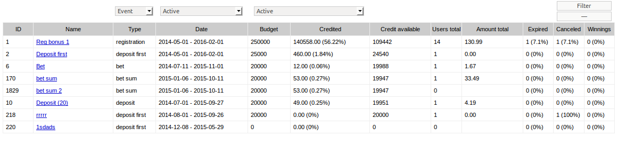
Detailed report shows bonus information by each bonus user
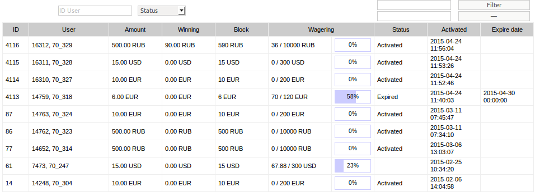

Bonus system also available for integration through API interface.

10 – Games
This section provide games and categories manager panel. You can use predefined categories and/or setup your own categories and relate them with games. As well as categories and games ordering also is manageable.
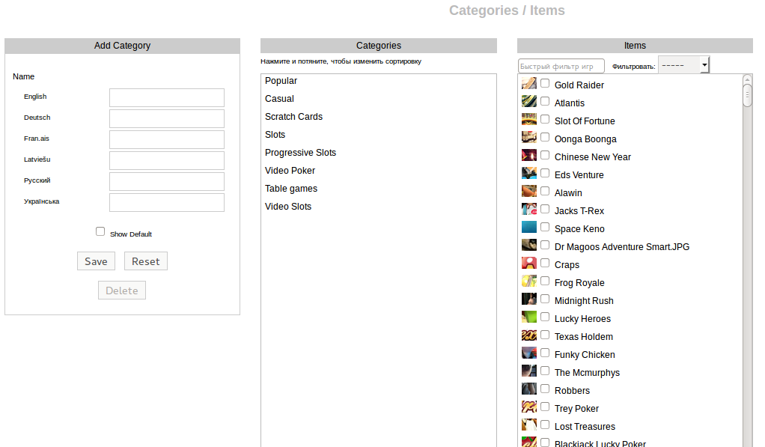
11 – Data extracts

Data extracts are available out of the box for major affiliate programs (IncomeAccess, etc.).
12 – Templating and API
Templating and API documentation is available at request.

